Fingerprint Module

Test Board Instruction

Table of Contents

1. **Introduction**
   1. What you’ll develop
   2. Supplies(Hardware, Software, other components)
2. **GPIO output / input**

2-1. External LED

2-2. Buzzer

2-3. Buttons

1. **Setting for debugging**

3-1. UART setting for ‘printf’

1. **16x2 LCD**

4-1. Wiring for 16x2 LCD

4-2. Library of LCD

1. **Connect board with fingerprint module**

5-1. Enroll

5-2. Identify

5-3. Verify

5-4. Delete

1. **Measure Temperature and humidity**

6-1. DHT11 Sensor

6-2. Print the result on LCD

1. **OS(Operating System)**

7-1. How to install RTOS on the board

1. **Multi threads**

8-1. How to run multi threads

8-2. Run fingerprint module program

8-3. Run DHT11 measurement

8-4. Run button tasks

**1. Instruction**

* 1. **What you’ll develop**

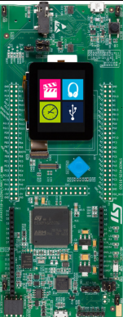

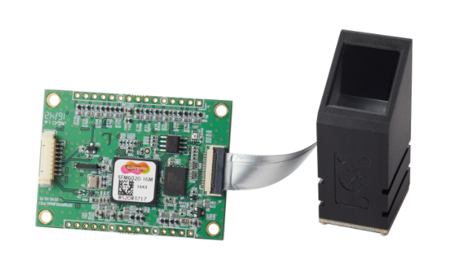

**<SFM6020> <SFM32F412ZGT>**

You are going to develop fingerprint module test board with ‘SFM6020’ and ‘SFM32F412ZGT’ board. SFM6020 is Suprema fingerprint module. SFM32F4 board is one of the opensource hardware boards. As following this instruction, you will put various components and sensors on the board to use functions of SFM 6020.

* 1. **Supplies**

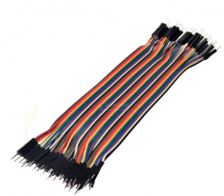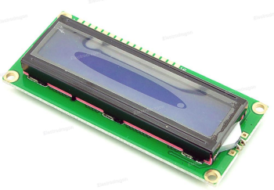

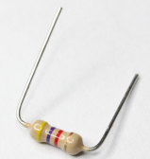

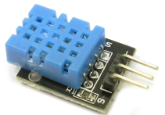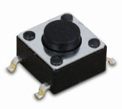

**<16x2 LCD> <Tact Switch x4> <Jumper wires> <DHT11 Sensor> <Resistors>**

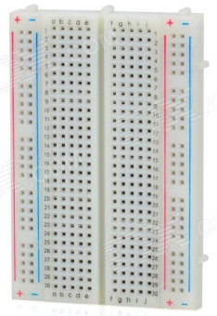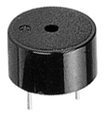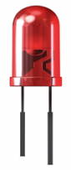

**<LED> <Buzzer> <Mini breadboard> <STM32F412ZG board> <SFM6020 module>**

Above pictures are components and hardware needed to develop the test board. Also you need software tools.

1. Install Keil Uvision5

https://www.keil.com/download/product/

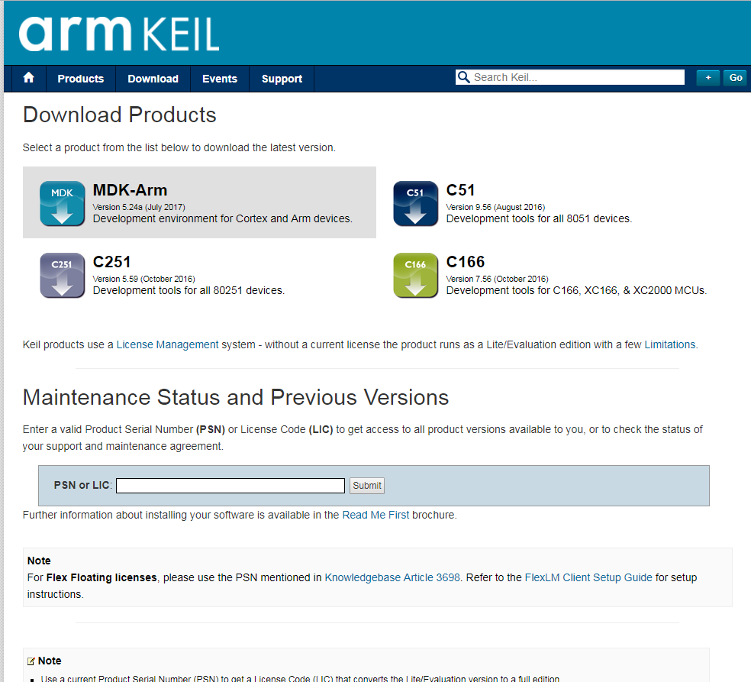

Go to the link and download program which is **MDK-Arm**.

1. Install STM32CubeMX

http://www.st.com/en/development-tools/stm32cubemx.html

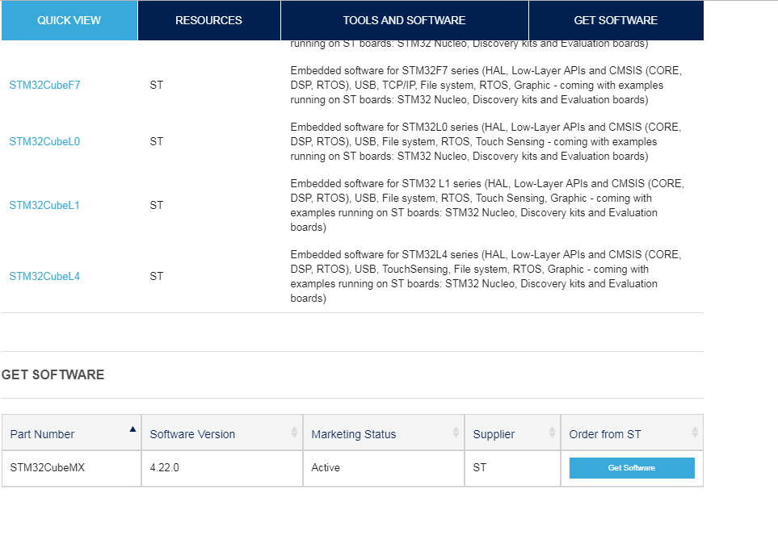

Download STM32CubeMX and click ‘New Project’. Then select the right board and click start project.

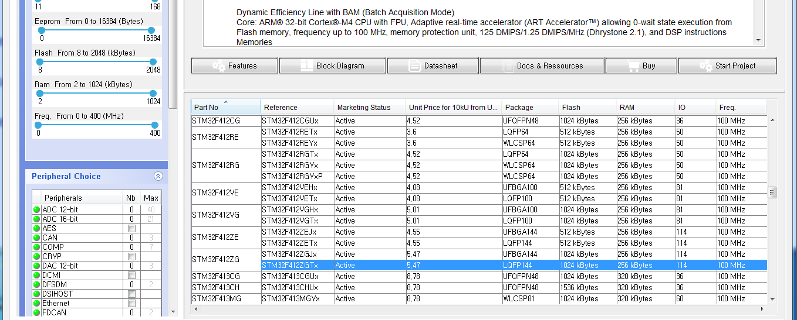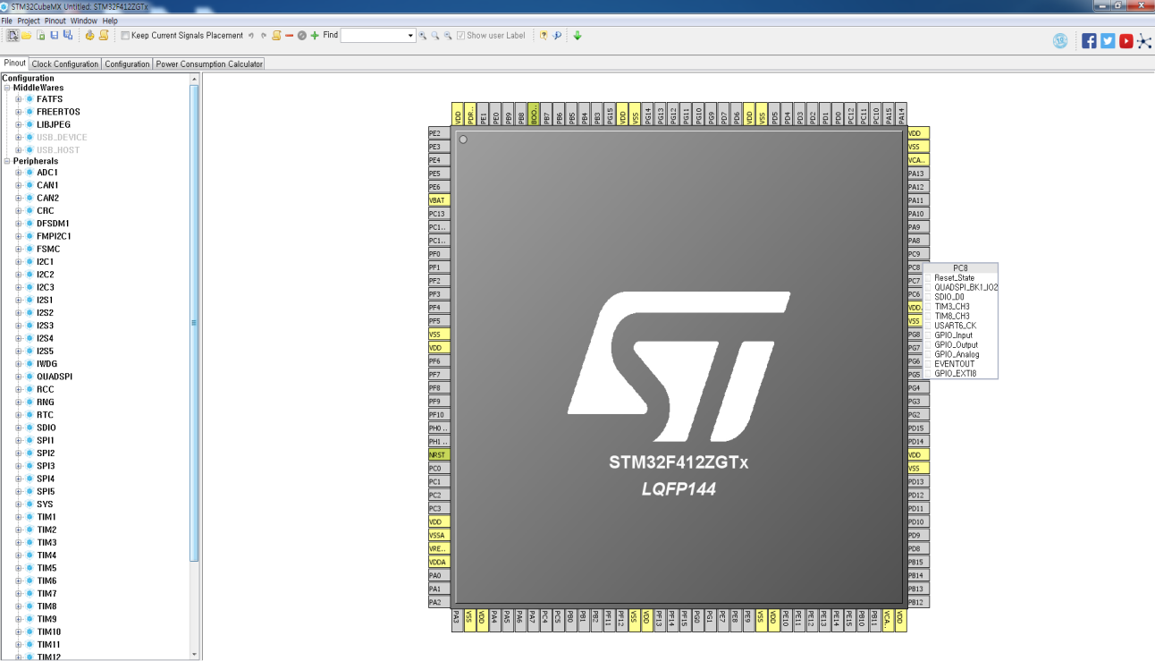After generated project, there are pins have various functions. If you want to generate code automatically, just click the pin name and pick a function you want to apply. Then set the pin name and click  this icon to generate code.

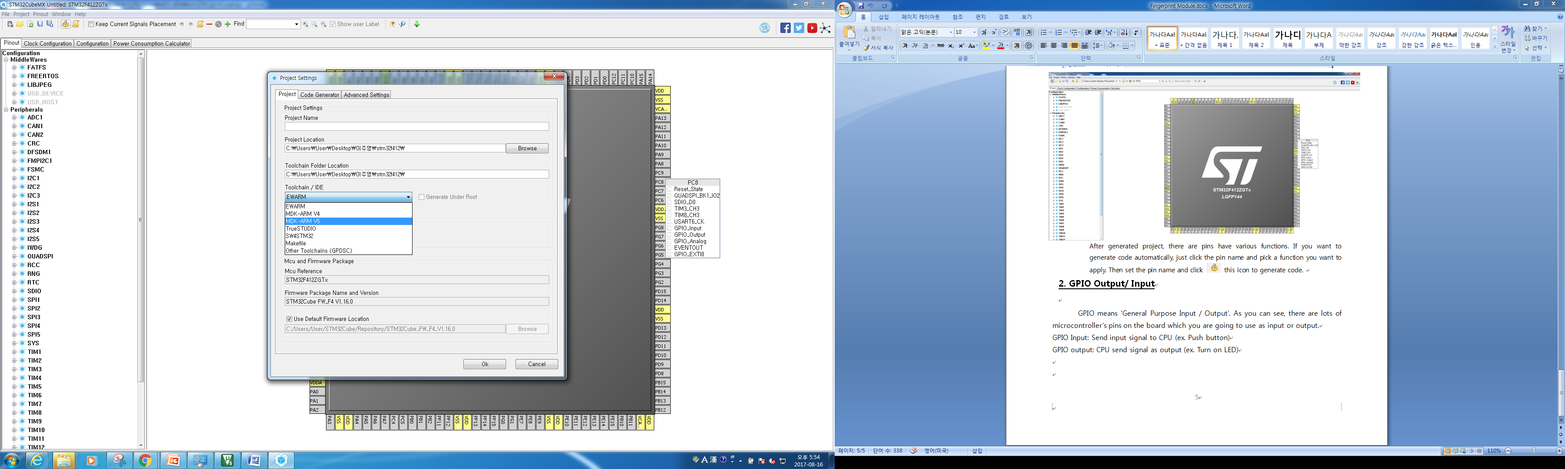

But you have to make sure to select **‘Toolchain/IDE’** as **‘MDK-ARM V5’.**

**2. GPIO Output/ Input**

GPIO means ‘General Purpose Input / Output’. As you can see, there are lots of microcontroller’s pins on the board which you are going to use as input or output.

GPIO Input: Send input signal to CPU (ex. Push button)

GPIO output: CPU send signal as output (ex. Turn on LED)

**2-1. External LED**

There are LEDs on the STM board, but to get used to how to set GPIO, you are going to control external LED like blinking.

**Supplies:** Jumper wires, LED, resistor, bread board

Firstly, if you look out the LED, one leg is longer and another one is shorter.

Longer one is to act positive so that it will be connected with pin as GPIO.

Shorter one is to act negative so that it will be connected with pin as GND (Ground).

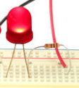Let’s start wiring up. Just put LED on the bread board and then set up the resistor like a left picture. One of the legs of resistor will be put on same line with LED’s shorter leg and another leg will be put on same line with jumper wire.

**GND**

And then connect the wire with GND pin on the board.

Next, choose one GPIO pin and then put the wire on same line with LED’s longer leg and put other side of the wire on the GPIO pin on the board.

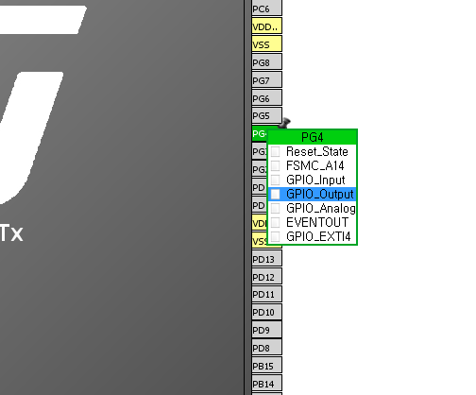

Turning on the LED is considered as GPIO output work. Therefore if you choose ‘PG4’, click the pin and select function as GPIO_Output. Then click ‘generate code’ if you want to generate code automatically.

Or there is another way to set the pin as GPIO output by generating code yourself.

First, open the ‘Keil uVision’ program.

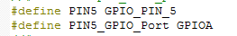Supposed to set it Pin ‘A5’, define the pin.

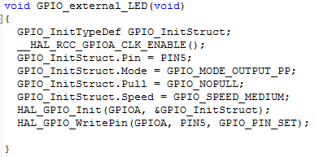You can change the name ‘PIN5’ to whatever you want like ‘LED1’.

Also you can set the name of ‘GPIO_InitTypeDef’.

Anyway set the pin’s mode as GPIO output and then write pin as ‘SET’ which means ‘Turn on’. And ‘RESET’ means ‘Turn off’.

To make the LED blink, turn it on and turn it off and repeat the work.

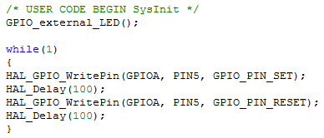So go to ‘main’, and then you need to init the GPIO pin.

Type the code like this. Then build and flash the file. And if you click the button on the board, you can watch blinking LED.

**2-2. Buzzer**

We need a buzzer to know functions work well or not. For example, if user succeeds to enroll his fingerprint, then ring the buzzer once, if he failed then ring the buzzer twice.

**Supplies: Buzzer, jumper wires, bread board.**

Buzzer is just same as LED. It has two legs, one is longer and another one is shorter. Shorter one will be connected to GND and longer one will be connected to GPIO pin.

Same as LED, you can set GPIO pin automatically using ‘CubeMX’ program or typing code yourself.

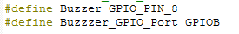First, you are going to define a pin as Buzzer’s GPIO pin. I choose ‘PB8’. It just set pin number and GPIO port. Then generate init function and ringing program.

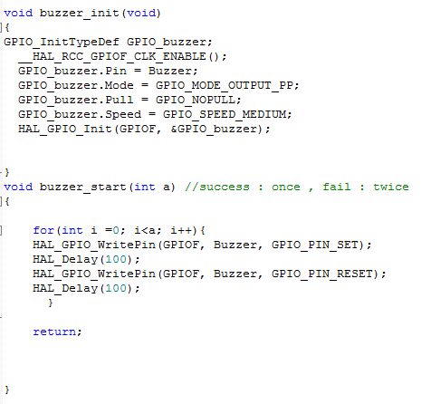First method is ‘buzzer_init’ which is needed to init buzzer’s GPIO. Set the GPIO mode as 'Output’.

Second method is ringing program. ‘GPIO_PIN_SET’ is to turn on the buzzer and ‘GPIO_PIN_RESET’ is to turn off the buzzer. Therefore to ring the buzzer you are going to repeat ‘SET’ the buzzer and ‘RESET’ the buzzer.

Whenever user uses ‘Enroll’, ‘Identify’, ‘Delete all’ functions, this function will be executed.



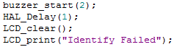

**2-3. Buttons**

Let’s set buttons for fingerprint functions. We need four buttons for ‘Starting program’, ‘Enroll’, ‘Identify’ and ‘Delete all’. As I mentioned, to push button to give signal to CPU is ‘GPIO Input’.

There are 3 pull modes as ‘Pull up’, ‘Pull down’, ‘No pull’.

First, ‘No pull’ is floating status which is no high, no low that means it is not connected to volt or ground.

‘High’ is connected to volt when switch is off. The other way, ‘Low’ is connected to ground.

If the I/O device gives signal or control the other device, floating status is dangerous because the other device cannot work correctly by misreading of the signal. So to prevent it, you need to set the mode to ‘Pull up’ or ‘Pull down’.

In my case, I set the buttons as Pull up so that it is high status(1) when the buttons are not pushed.

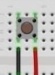**Supplies:** Jumper wires, 4 tact switches, bread board.

Put the switch and wires on bread board. Then let’s set the gpio.

**GPIO**

**GND**

Like LED and buzzer, you can set a pin as GPIO_Input by using CubeMX program.

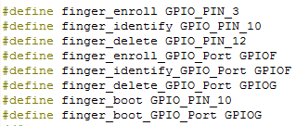In your code, at first, define the buttons’ pins and ports. Then you need to init the pins.

The ‘finger_boot’ button is for ‘Start program’.

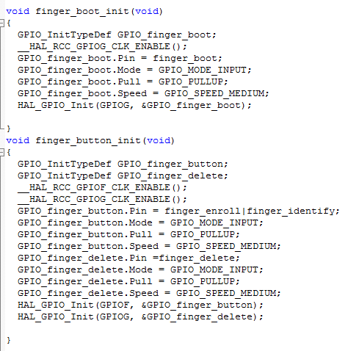As I mentioned above, set the pin’s pull mode to pull up.

And look out the ‘finger_button_init ‘function. When you set more than two pins which are in same port, you can define them together by using ‘|’.

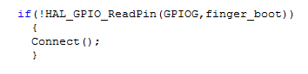

At next part, you are going to use these buttons to execute functions. In the part, CPU needs to read the signal the button sent.

‘HAL_GPIO_ReadPin’ method is for reading pin’s status. But because pin’s status is set to pull up which is high(1), if user pushes the button it will be low(0). So you need to execute the function when the pin’s status is low.

**3. Setting for debugging**

**3-1. UART setting for ‘printf’**

When you want to test the code executes correctly, you would want to use ‘printf’. By UART(Universal Asynchronous Serial Receiver and Transmitter) communication, you can use ‘printf’. There are some steps to set UART for printf.

First, you need to a software program named as ‘Xshell5’.

Download link: <https://www.netsarang.co.kr/download/down_xsh.html>

Go to the link and download the program.

Tutorial link: <https://www.netsarang.co.kr/tutorial/xshell/1404>

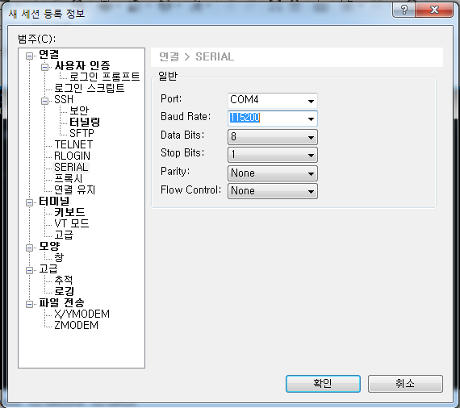If you go to the second link, you can learn how to use the program.

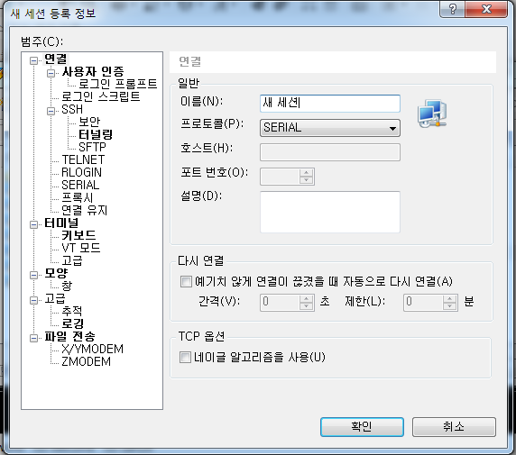 When you create new session, you need to select ‘SERIAL’ connection. And go to ‘SERIAL’ and select the port of the STMboard which is ‘COM4 ‘ in my case. Then set the ‘Baud Rate’ to 115200.

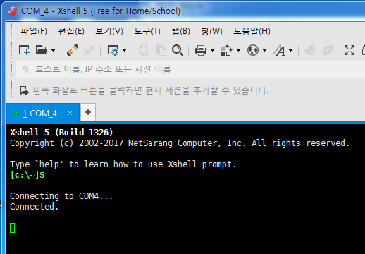And click ok, the terminal have to show the board is connected to the port. This terminal will show the result of ‘printf’ of your code.

Next, let’s move on to set UART communication of the board. \

Open the CubeMX, and look out ‘Pinout’ section. There are various functions that you can use. There are 4 UART; UART1, UART2, UART3, UART6 on the board.

Among the 4 UART, USATR2 is going to be used to send printable value to computer via port COM4. Therefore, click the UART2 and set the mode to Asynchronous. And you can discover the pins are already set for UART2.

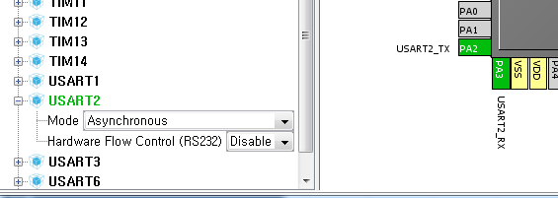

To use UART, you need to set lots of things so that it is better to generate code automatically through the program. So click  this icon to generate code.

Before that, you have to keep in mind that you have to **close ‘Keil’** because if Keil is opened during generating code through CubeMX, CubeMX would be stopped and the code in Keil you implemented could be deleted.

Finished generating code, click the open project. And insert below code into ‘main.c’. But it should be inserted out of ‘int main()’

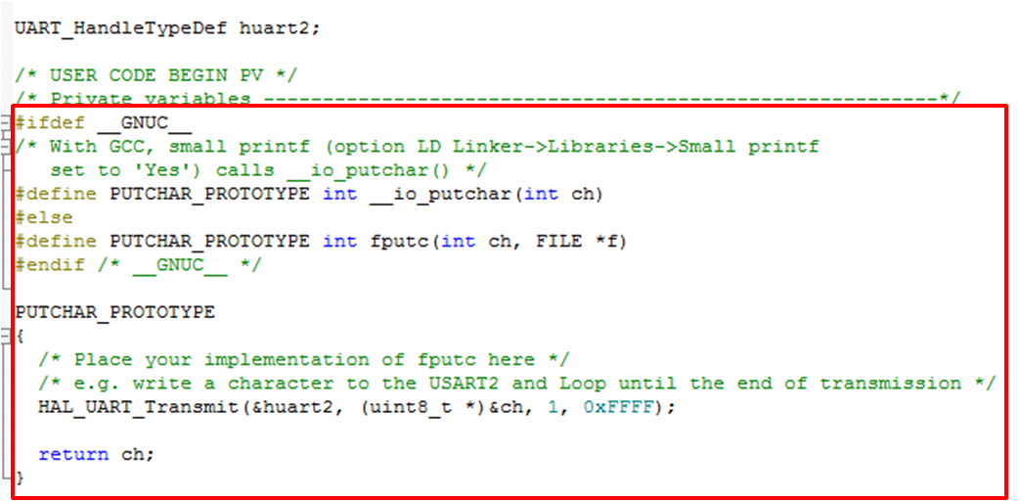

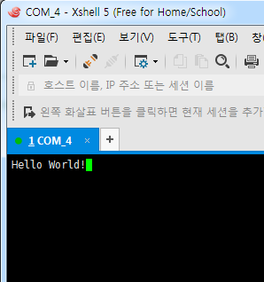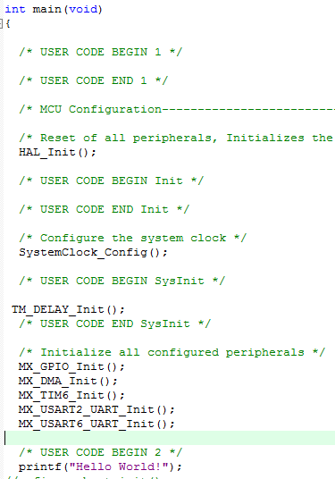

In int main(), insert init functions for system and then write ‘printf’ to print “Hello World!”.

If you build(F7), and flash(F8), and run the program, you can see the sentence on the terminal of Xshell5.

**4. 16x2 LCD**

Now you can see result of test through terminal in PC. However, you need to check the result through the display on the board not PC. Therefore, we are going to put 16x2 LCD on the board.

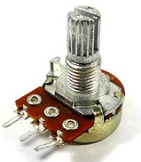**4-1. Wiring for 16x2 LCD**

**Supplies:** Jumper wires, 16x2 LCD, resistor, bread board.

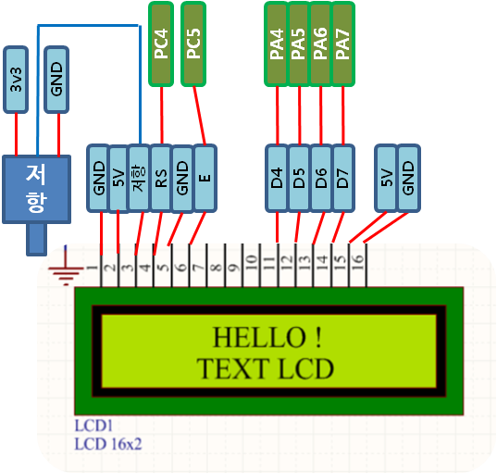In this case, I used ‘Potentiometer(가변 저항)’ which is for brightness control of LCD like right side picture.

**<Potentiometer>>**

Set up the wiring for LCD same with the left picture.

You have to set the pins have not used before. If a pin is set to execute more than 2 functions, it would not work correctly.

**4-2. Library of LCD**

<https://drive.google.com/file/d/0B5Vl-vFC9JLbVG9YemV0SWxEbVk/view?usp=sharing>

Go to above link to download a library for LCD.

<https://www.youtube.com/watch?v=F8bCEZPbjeU>

If you go to the above link, you can learn how to use this library.

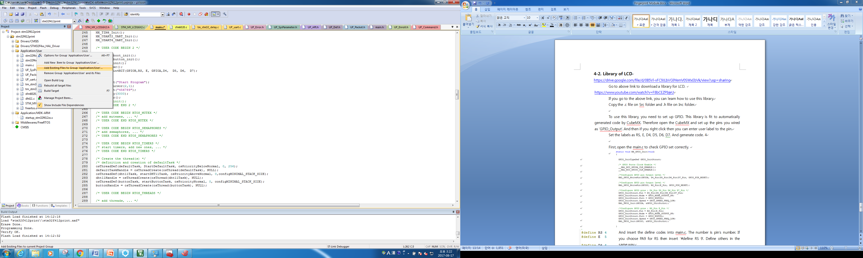 Copy the .c file on Src folder and .h file on Inc folder.

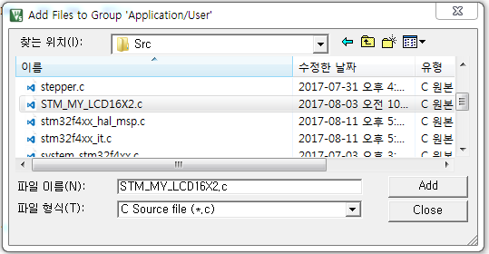

Open the Keil, right click on Application/User folder and select ‘Add Existing File’.

Then add C source file which named ‘STM_MY_LCD16X2.c’ .

 Next, go to main.c file, include the header file.

To use this library, you need to set up GPIO. This library is fit to automatically generated code by CubeMX. Therefore open the CubeMX and set up the pins you wired as ‘GPIO_Output’. And then if you right click then you can enter user label to the pin.

Set the labels as RS, E, D4, D5, D6, D7. And generate code. 4

First, open the main.c to check GPIO set correctly.

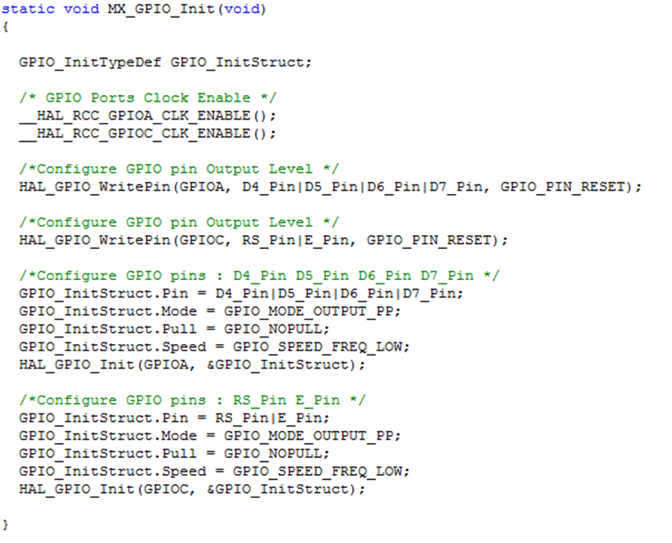

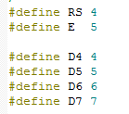

And insert the define codes into main.c. The number is pin’s number. If you choose PA9 for RS then insert ‘#define RS 9’. Define others in the same way.

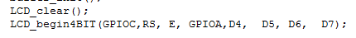

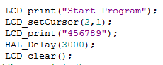And into int main(), insert the code to clear LCD and to set LCD for 4bits execution.

LCD_print(“ ”) : print string on LCD

LCD_setCursor(row, column) : set cursor

LCD_clear( ): erase the string on LCD

* Mainly used methods

**5. Connect board with fingerprint module**

Now, it’s time to connect the board with fingerprint module.

To communicate with the module, we need to set up UART and wiring.

**Supplies:** SFM6020 module, STMboard, jumper wires.

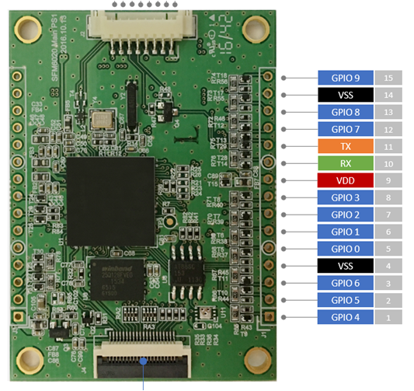You are going to make communicate available between SFM6020 and UART6 on the STMboard.

Left picture is a pin map of SFM6020. You are going to use TX(11), RX(10) and VSS(14 or 4).

Before wiring up, you need to understand why TX is connected to RX of STMboard and RX is connected to TX of STMboard.

When user executes STM32 and it will send signal to SFM6020 to execute the fingerprint module. After fingerprint module got user’s data, it will send the data to SFM6020 and then SFM6020 will process the data. Then to show result through components on the STM board, SFM6020 will send processed data to STM board.

**SEND (TX)**

**RECEIVE (RX)**

STM32F4

**SEND (TX)**

**RECEIVE (RX)**

SFM6020

To set up the UART of STM board, open CubeMx. In ‘Pinout’, you can find out USART6. Set the mode as ‘Asynchronous’ then you can see the ‘PC6’ is set to TX and ‘PC7’ is set to RX. Therefore pin 10(RX) of SFM will connect to PC6 and pin 11(TX) of SFM will connect to PC7. Lastly, VSS (14) will connect to GND on the board.

Then generate code!

Finally, wiring is finished. Let’s set up the SFM6020 program on the STM board.

Download Library Link: <https://github.com/supremainc/SFMTEST_STM32F4>

Go to the link and download the files. But for this project, you do not need all of files in those folders.

In Src folder, you need main.c, UF_Packet.c, UF_SysParameter.c, UF_uart.c.

In Inc folder, main.h, UF_API.h, UF_Command.h, UF_Def.h, UF_Enroll.h, UF_Error.h, UF_Packet.h, UF_SysParameter.

In the same way of including library files of LCD, copy .c files to Src folder and .h files to Inc folder of STM project except main.c and main.h.

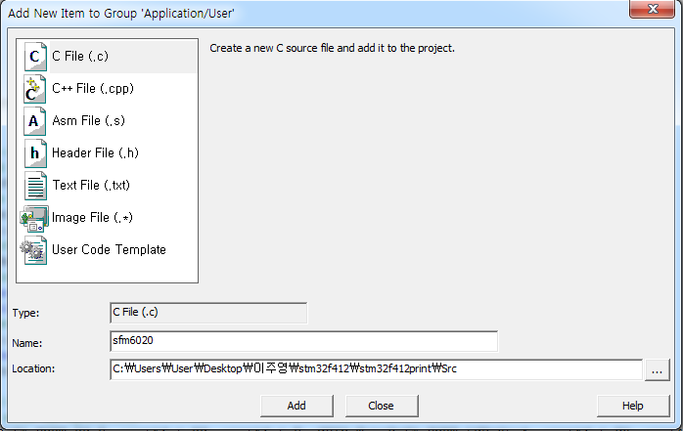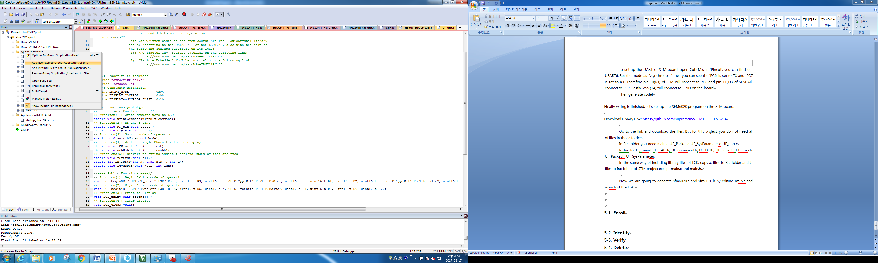 Now, we are going to generate sfm6020.c and sfm6020.h editing main.c and main.h of the link.

Right click on the Application/User, click ‘Add New item’. Then, select C File named ‘sfm6020’. And you need to set location to Src under the project.

<https://github.com/supremainc/SFMTEST_STM32F4/blob/master/Src/main.c>

Above link is code of main SFM6020 program body. We will edit this code to ‘sfm6020.c’.

1. 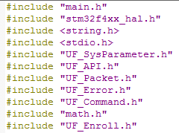Go to the link and copy and paste ‘include’ part into sfm6020.c .
2. In the link, you can find out below part. It is similar with the code you inserted for function of printf. Copy the different part and go to the main.c of stm32f4 project and paste the code to change it like below.

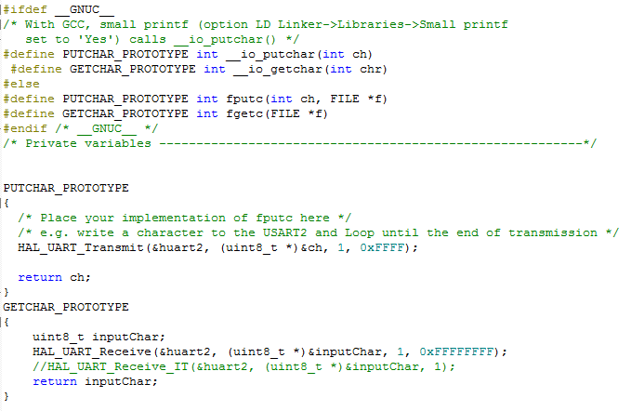

1. Go back to the link. Copy the below part(line 69-72)and paste it to ‘sfm6020.c’ below include part.

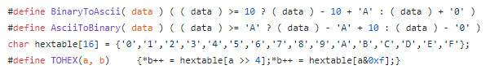

1. Go back to the link. Copy line 100-161, 182-193 and 273-1097, paste it to ‘sfm6020.c’.

Now let’s add sfm6020.h! Right click on the Application/User, click ‘Add New item’. Then, select Header File named ‘sfm6020’. And you need to set location to Inc under the project.

<https://github.com/supremainc/SFMTEST_STM32F4/blob/master/Inc/main.h>

Above link is code of header file. We will edit this code to ‘sfm6020.h’.

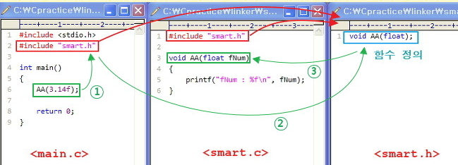

The picture shows how execute the main.exe file and why we need to make headerfile and include it into all c files which use methods defined in the headerfile.

If you want more specific information of it, go to below link. <http://zapiro.tistory.com/entry/%EB%8B%A4%EC%88%98%EC%9D%98-%ED%8C%8C%EC%9D%BC%EB%A1%9C-%EB%82%98%EB%88%84%EC%96%B4-%EC%9E%91%EC%97%85%ED%95%98%EA%B8%B0>

Let’s edit sfm6020.h

1. Define parameters used in sfm6020.c. Go to the github for main.h link and copy line 51-53 and paste into sfm6020.h
2. Define functions used in sfm6020.c. Go to the main.h and copy line 70-98 and paste into sfm6020.h.

You are going to change UART setting of sfm6020.c to fit your UART setting. Let’s start.

In original file(main.c in github), UART setting for communication was set to UART1 but your UART setting is UART6. But you already defined UART6 in main.c in your project. So if you just add the definition, it occur an error. Therefore you have to add ‘extern’ in front of the definition.

Add below codes under the ‘#include’ part.

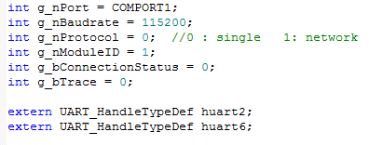

Type ‘Ctrl+F’. And replace all ‘huart1’ to ‘huart6’. Now UART setting is finished.

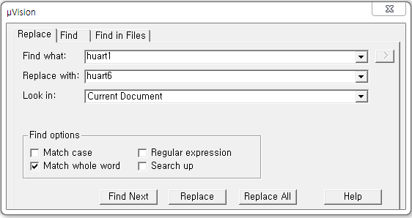

Actually, the codes you copied are for USB communication, not serial. So this program would not work well. Let’s edit functions we need.

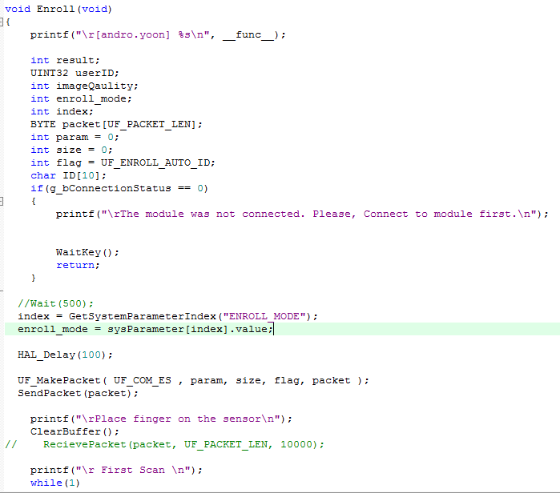**5-1. Enroll**

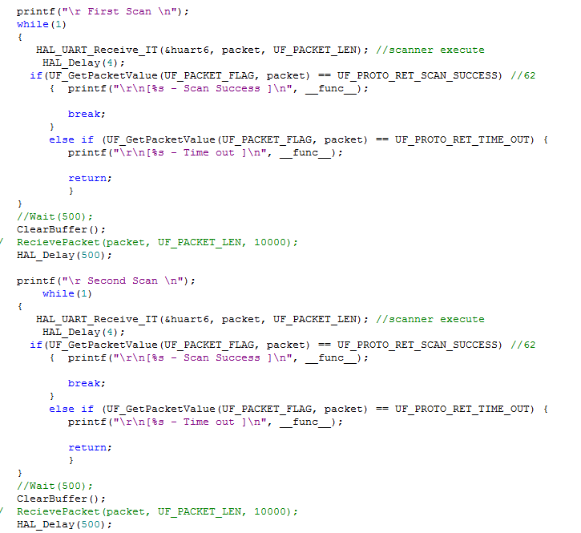

**d**

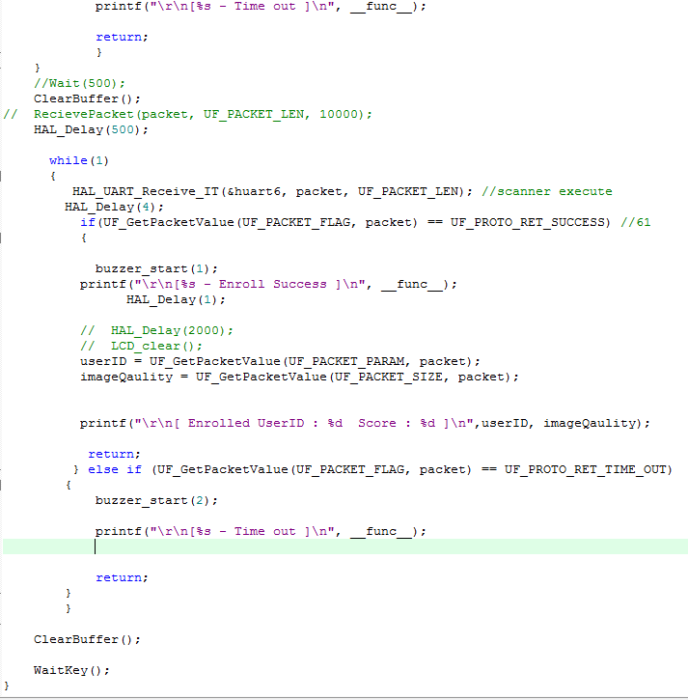

**<Explanation of part of the code>**

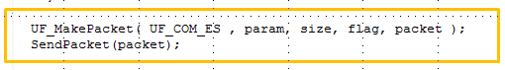This part is for creating enroll packet. And send the packet to sfm6020.

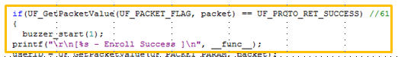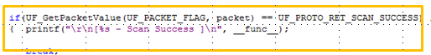In this part, STM board checks the packet status. If user success to enroll the fingerprint,

Buzzer rings once.

Or not, Buzzer rings twice.

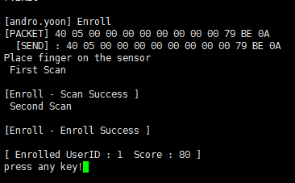

**<Result>**

**5-2. Identify**

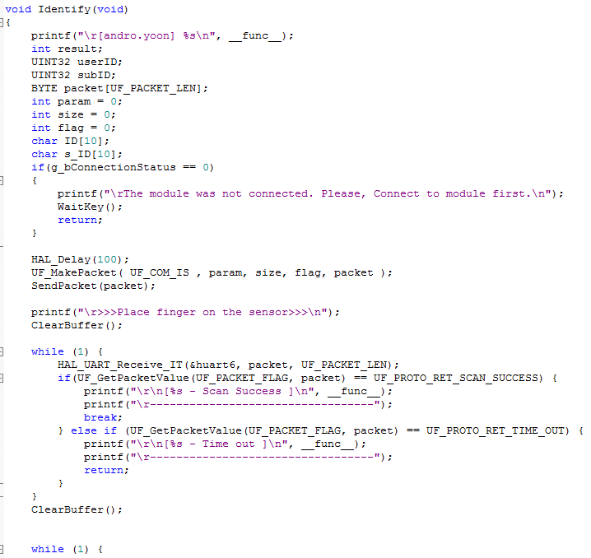

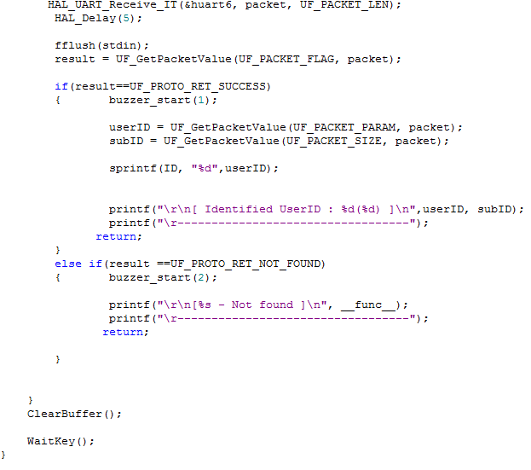

**<Explanation of part of the code>**

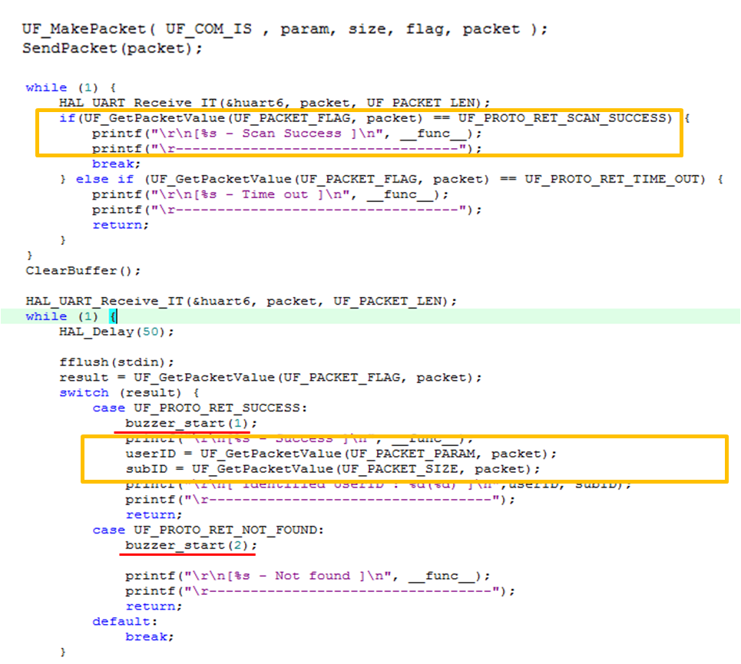

Flag: result of scan

Param: result of identified ID

Size: result of identified sub ID

(sub ID could be different -> doesn’t matter)

If user success to identify the ID,

Buzzer rings once.

Or not, Buzzer rings twice.

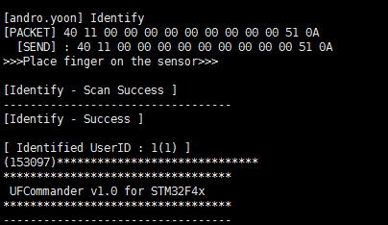

**<Result>**

**5-3. Verify**

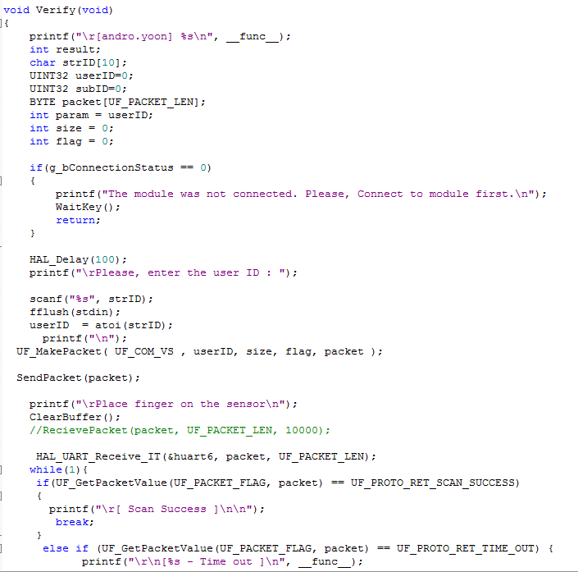

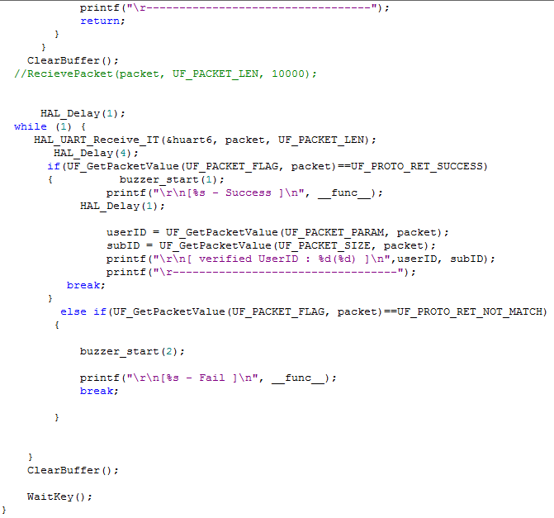

**<Explanation of part of the code>**

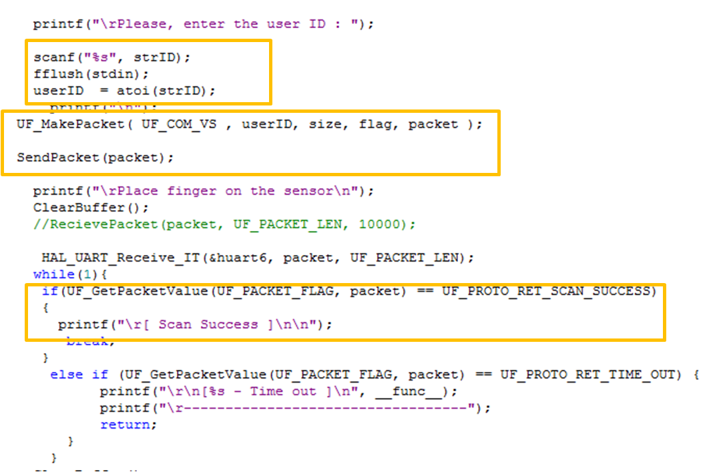Type ID user want to verify

gets(strID) -> scanf

gets() has security problem -> execution and compile error.

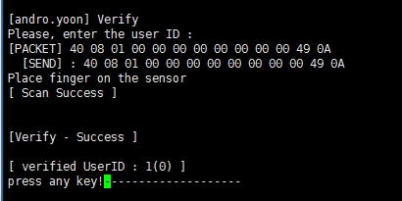

**<Result>**

**5-4. Delete all**

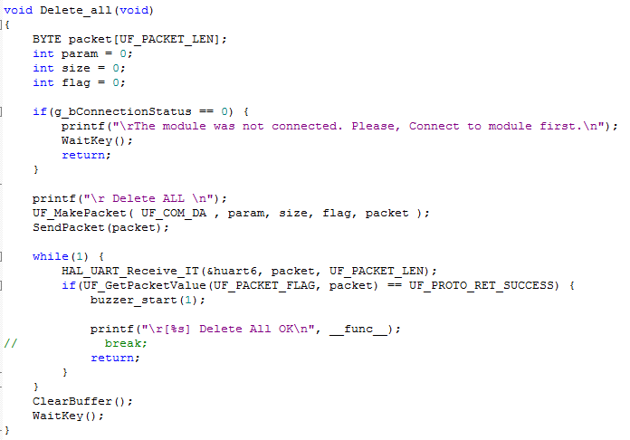

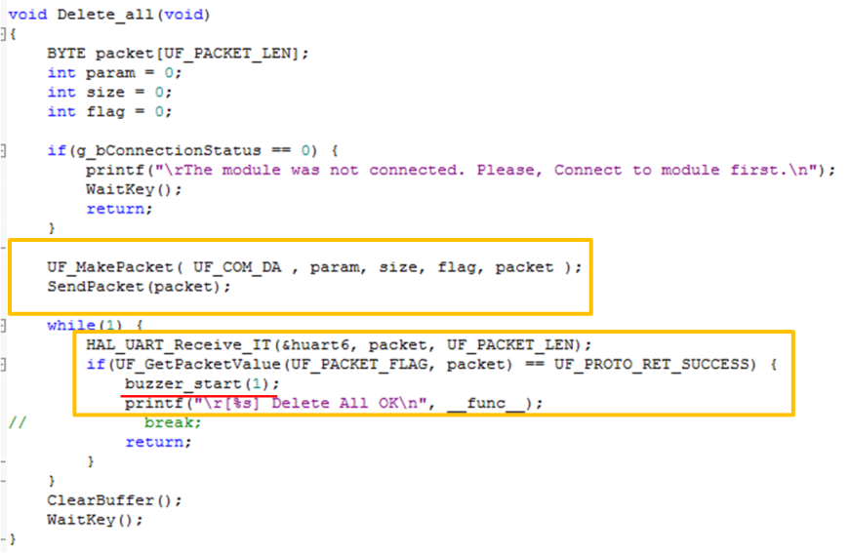 **<Explanation of part of the code>**

Create packet and send it.

If user success to delete all data,

Buzzer rings once.

Or not, buzzer rings twice.

**6. Measure Temperature and humidity**

Now setting for SFM6020 module is finished. You are going to put DHT11 sensor on STM board to measure temperature and humidity.

**6-1. DHT11 Sensor**

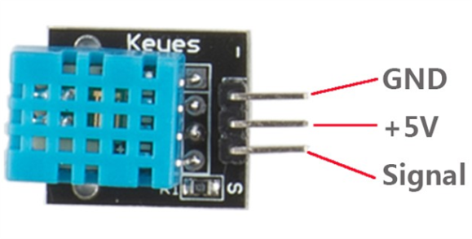

Above picture is DHT11 sensor. You can find out there is only one signal pin to communicate. That means this sensor communicates as ‘Input’ and ‘Output’ through one wire with the board.

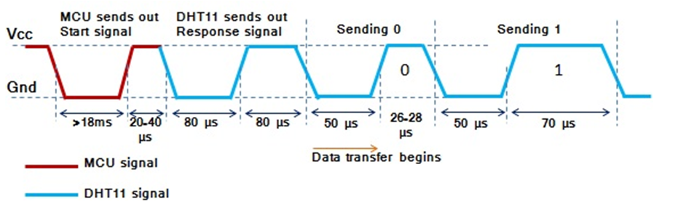

Above picture shows how it works. Based on this picture, you are going to implement to make it work.

You have to notice MCU signal is ‘GPIO Output’ signal which is for connection part and DHT11 signal is ‘GPIO Input’ signal for data transmit part.

At both part, low is 0 and high is 1.

In DHT11 signal part, DHT11 send total 40bits which are formed like below structure.

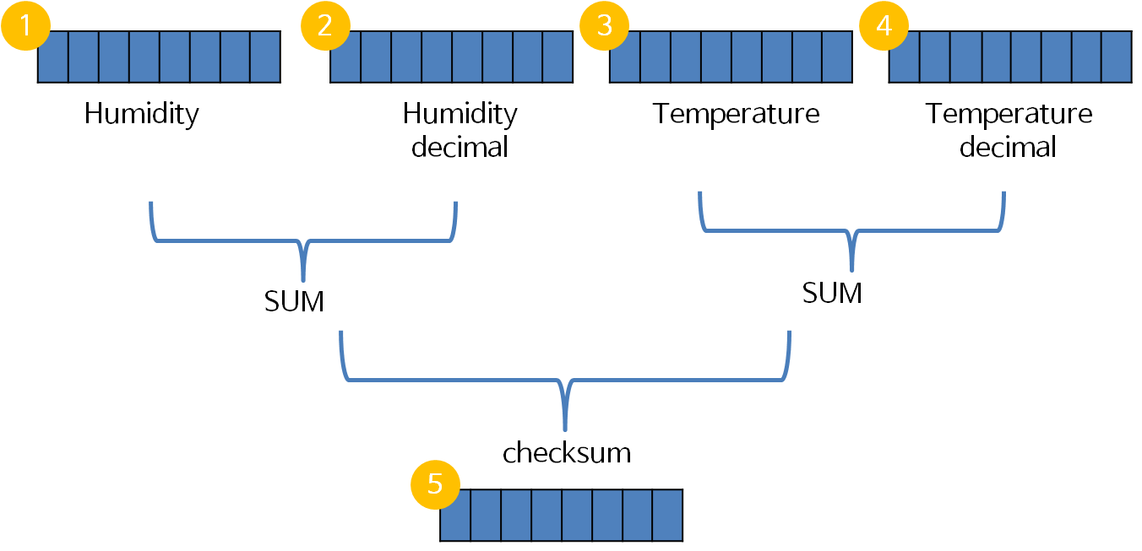

That means 8bits * 5 = 40bits. Checksum should be same with sum of humidity, humidity decimal, temperature and temperature decimal. If it isn’t, the data has an error.

At first, we will create dht11.c and dht11.h files to implement DHT11sensor individually. And we will include it into SFM6020’s function to read temperature and humidity when users execute SFM6020 module.



1. Add new item on Application/user folder.

2. Set the file name as ‘dht11.c’and location to Src folder of the project.

At first, you should include header files to use functions you need.

In HAL library, there is ‘HAL_Delay’ to give a delay to CPU millisecond unit. But to implement DHT11 sensor, it needs delay in microsecond unit. Therefore we will download ‘microsecond delay’ library.

*1000microsecond = 1 millisecond

<https://github.com/MaJerle/stm32fxxx_hal_libraries/tree/master/00-STM32_LIBRARIES>

Go to the link, and download libraries below list.

tm_stm32_delay.c

tm_stm32_gpio.c

defines.h

tm_stm32_delay.h

tm_stm32_gpio.h

stm32fxxx_hal.h

tm_stm32_rcc.h

Then copy .c files into Src folder and .h files into Inc folder.

Next, open the define.h file and edit like this.

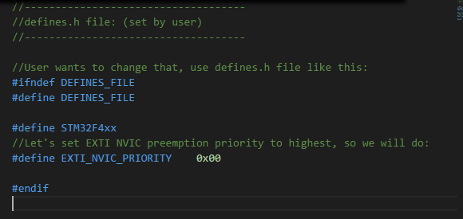

Save file and close it.

Now add new item on Application/user folder.

At first, you need to include header files to be used.

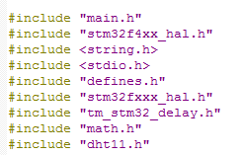

Next, you will save the data into variables; humidity and temperature and checksum. So add the values.

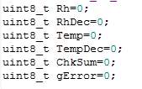

gError is for checking the final data has an error or not.

Now you have to set GPIO pin to communicate with DHT11 sensor.

I selected PF4.

So, define the GPIO pin name and port before define functions.

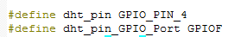

As I mentioned before, this is one wire data process. So we need ‘output init’ and ‘input init’ both.

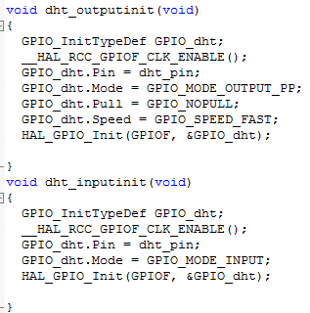

**<DHT11 READ>**

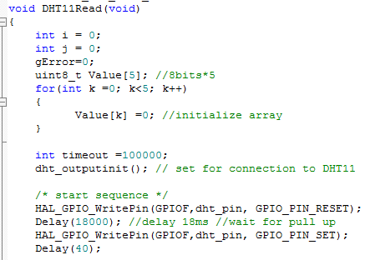

 Set DHT11’s data wire to output to connection.

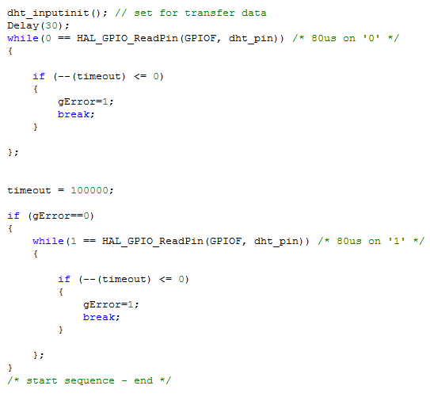

Change GPIO function to input. This process is for setting up to transmit data.

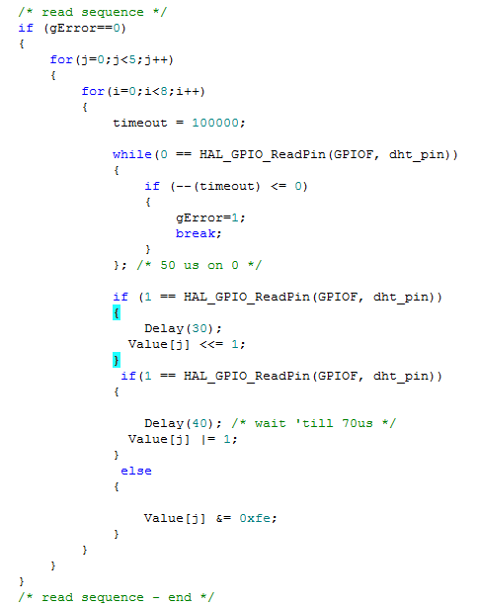



Data transmission part is end. Now we have to check the value is valid data.

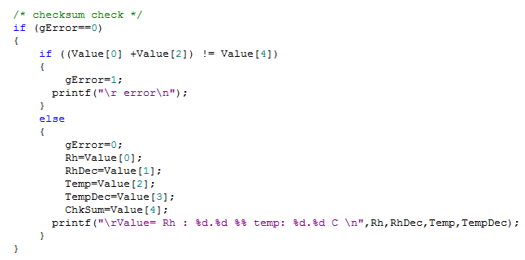

Actually DHT11 doesn’t send RhDec value and TempDec value so that the data is always zero(0). So to check the checksum, just sum of Value[0] (Rh ) and Value[2] (Temperature).

If the data is valid, then save the values and print them. And set gError’s value to be 0.

If the data is invalid, print error message and set gError’s value to be 1.

In case of that you need just result of saved values, you need a function to print them.

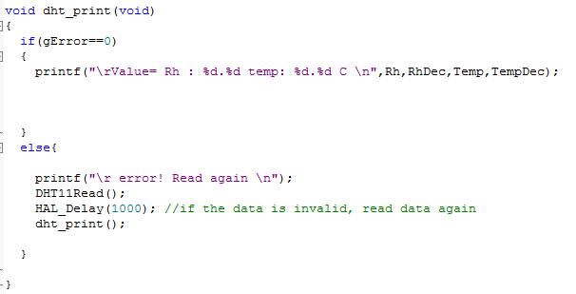

But it just prints on terminal of your pc. If you don’t have pc or terminal program, you cannot check the result. So we are going to print the result on LCD which was put on last step.

**6-2. Print the result on LCD**

To print on LCD, you need LCD library’s function. So include the header file on top of this c file.



Now you can use any functions in LCD library.

Before use the print function, you have to know you can print only ‘char’ value on LCD. Therefore you are going to use ‘sprintf’ function to change the format of value.

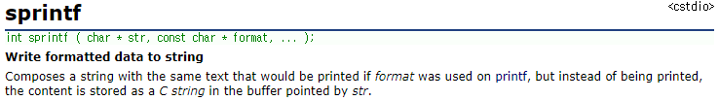

And I am going to print it on LCD only if the value is valid.

Therefore print only gError is 0.

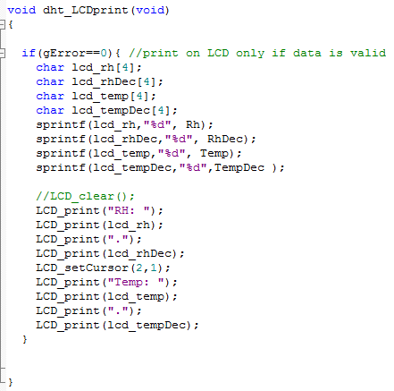

Also you need to create dht11.h.

Just add all of definition of functions that used in dht11.c in the header file.

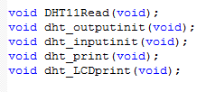

**7. OS(Operating System)**

Embedded platform is consisted with CPU(board), OS and IDE(edit tool; ex eclips, keil .. ).

There are 2 types of OS which are NON-RTOS and RTOS. Also some program doesn’t use OS. In that case, the number of tasks is really small and the program doesn’t need to guarantee priorities between tasks and simultaneous access to resource.

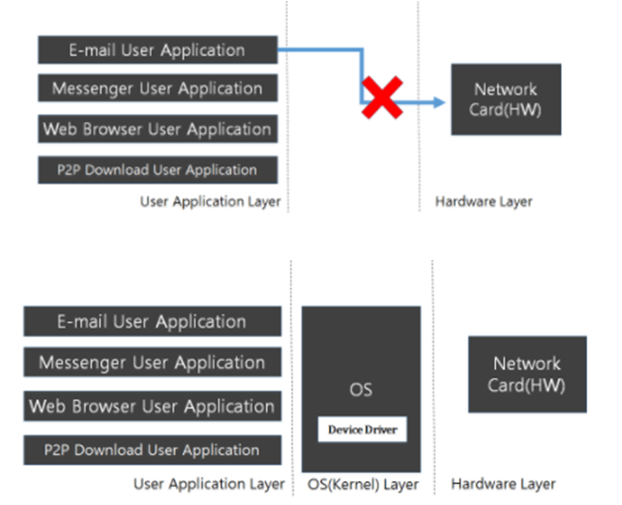

RTOS means Real Time Operating System. It doesn’t have lots of tasks but it should guarantee priorities between tasks.

The difference between NON-RTOS and RTOS is constitution of each task

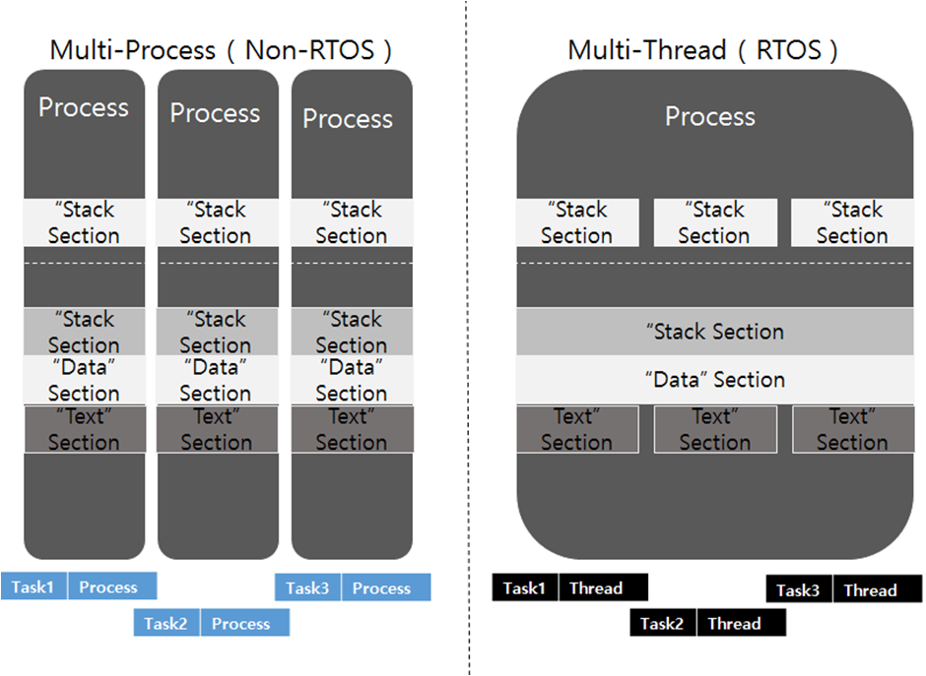

NON-RTOS’s task consists of process but in case of RTOS, it consists of thread.

So NON-RTOS is multi process OS and RTOS is multi thread OS.

In this project, we are going to use RTOS. Then, what does multi thread mean?

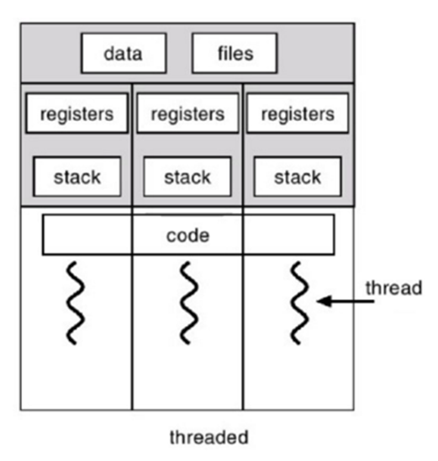

This picture is good to explain multi thread.

There are many threads in one process.

So they are sharing memory space of the process.

Therefore, they share data and file which are global variable.

But they have each register and stack for execution of each thread.

Then let’s install RTOS on the board.

**7-1. How to install RTOS on the board**

We will use FreeRTOS which is available to install via CubeMX.

Open the CubeMX.

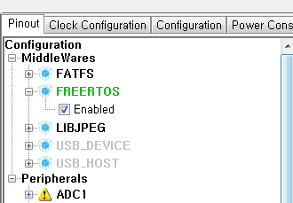In ‘Pinout’ setting, check ‘Enabled’ of FreeRTOS.

And close opened ‘Keil’ program and next, generate code and open the project.

If you want to set FREERTOS, then go to configuration menu in CubeMX.

If you open the project, lots of things are changed to make RTOS available.

**8. Multi threads**

Now your project is available to create multiple threads.

**8-1. How to run multi threads**

This is sequence of generation of thread.

1. Define thread’s name



1. Define function.



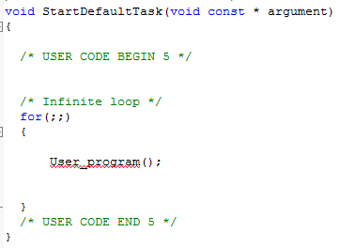

1. In main, after system init, create thread.



You can set the function’s priority and stack’s size by yourself.

Now generate threads for running fingerprint module, DHT11 sensor and buttons.

**8-2. Run fingerprint module program**

I set default task to start sfm6020 module.

And it will start connection to sfm6020 module when user pressed ‘Start program’ button.

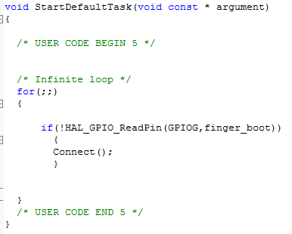



And you have to set the priority to ‘**osPriorityBelowNormal**’ because DHT11 is really sensitive sensor by delay so it should not get interrupt by other tasks. So DHT11’s thread will get highest priority.

And Button task‘s priority should be higher than Starting program because when users press the button, it should work immediately.

**8-3. Run DHT11 measurement**



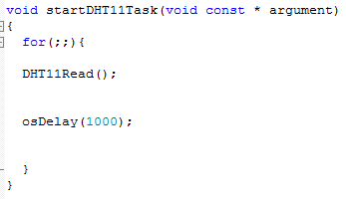

Set thread’s name and function.

When threads are working, CPU can aware only **osDelay** not HAL_Delay function.

osDelay is also millisecond unit delay function same as HAL_Delay function.

As I mentioned above, its priority should be highest in this project.

So you are going to set the priority ‘aboveNormal’.

But if you set stack’s size large, it could conflict with other tasks so that set the size to be minimal. Also to execute DHT11 sensor, this project should include DHT11 library. So add dht11’s header file on top of the project like below.



**8-4. Run button tasks**

If user pressed Enroll or Identify or Delete all buttons, the board has to execute sfm6020 module immediately.



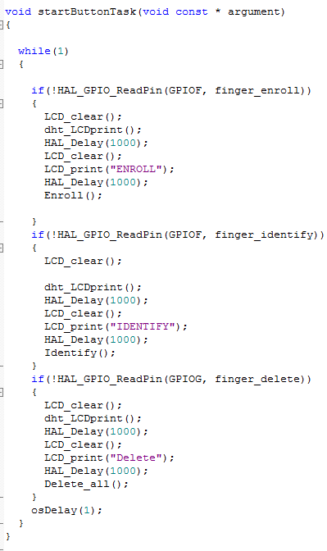Also LCD should print what button is pressed.

So you’ll include LCD print function as well.

To use LCD function, you need to include LCD library’s header file. So top of the project, include the header file.



After printing the name of function on LED, execute the function in sfm6020.c.

Of course you have to include the sfm6020.h on top of the project, too.





And set the priority to lower than DHT11 and higher than default task. And also its stack size should be minimal size.

Now let’s edit ‘sfm6020.c’ to show all execution’s result on LCD.

1. First, you need to include LCD’s header file and DHT11’s headerfile.

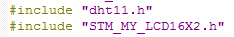

1. if user pressed ‘Start program’ button, thread executes Connect( ).

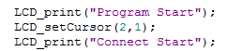

To print the status of connecting, just add the ‘LCD_print’ lines on appropriate position.

1. Also you can add that line at any functions in sfm6020.c to show status of process of the function. Just change the message.
2. If you look out the sfm6020.c, all functions SFMboard are going to execute is ended to ‘WaitKey( )’.

This test board should show the temperature and humidity on LCD after finished all execution.

So go to the WaitKey( ).

And edit to work dht_LCDprint( ) function.

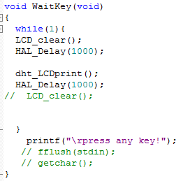

1. If user press Identify button, LCD should print the identified ID.

You can apply ‘sprintf’ function change identified ID to ‘char’ value.

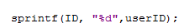

**Lastly, on STM32F4 board, there is Arduino Uno V3 Connectors.**

**Most shields designed for Arduino Uno V3 can fit to the 32F412GDISCOVERY discovery kit. So if you change pin set to Arduino Uno connector, you can convert any Arduino board and other opensource hw board.**

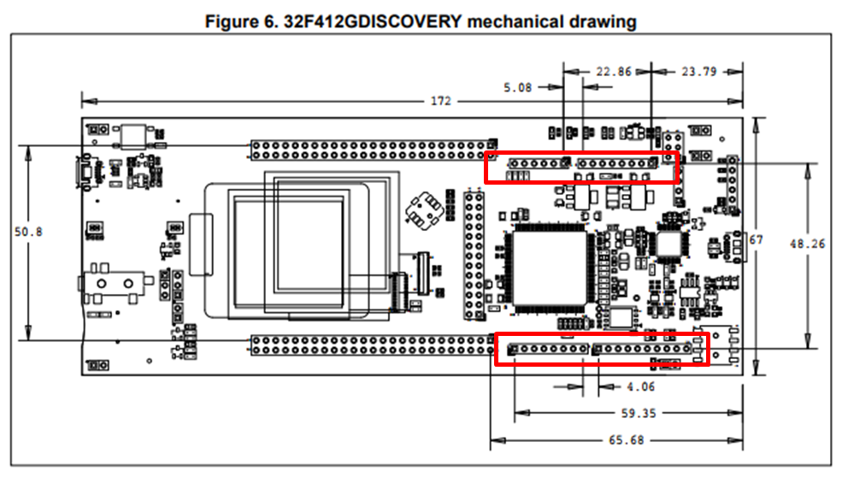

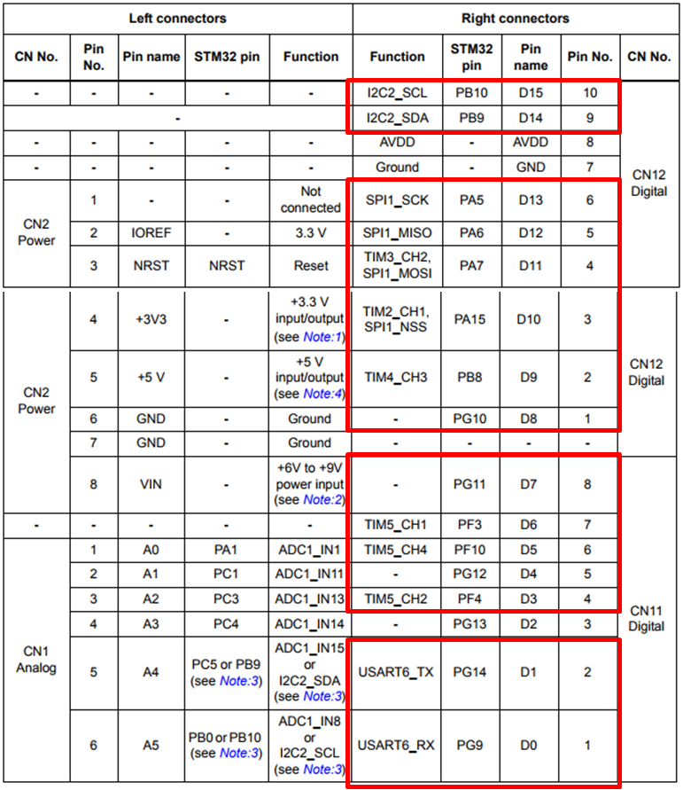

**Red Boxes are pins I used.**

**<Pin set list>**

**D15 – LED E (PB10)**

**D14 – LED RS (PB9)**

**D13 – LED D4 (PA5)**

**D12 – LED D5 (PA6)**

**D11 – LED D6 (PA7)**

**D10 – LED D7 (PA8)**

**D9 – Buzzer (PB8)**

**D8 – Start Button (PG10)**

**D6 – Enroll Button (PF3)**

**D5 – Identify Button (PF10)**

**D4 – Delete Button (PG12)**

**D3 – DHT11 (PF4)**

**D1 – USART6 TX (PG14)**

**D0 – USART6 RX (PG9)**

**To convert pinset,**

1. **Reset Wiring of all components.**
2. **Change all GPIO setting of Main.c, dht11.c, sfm6020.c, header file**
3. **Change setting of GPIO read, write, port clock**

**It’s end of this project. If you want to refer the code go to the link below.**

[**https://github.com/Juyounglee95/suprema**](https://github.com/Juyounglee95/suprema)